Parinama Academy
Credit By Exam Grade VII-ELA
Arena 1 |  | Arena 2 |  | Arena 3
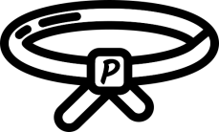  White Belt 1 | 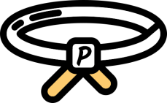  White Belt 2 | 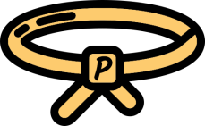  Yellow Belt 1 | 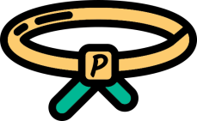  Yellow Belt 2 | GreenBelt 1 | PRACTICE AND FINAL ASSESSMENT
Min: 4 Weeks,  Max:8 Weeks | Min: 3 weeks,  Max: 6 weeks | Min: 4 weeks,  Max: 8 Weeks | Min: 3 weeks,  Max: 6 weeks | Min: 4 weeks,  Max: 8 Weeks | Min: 3 weeks  Max: 6 weeks
Min: 1 Month & 3 weeks  Max: 3 Months & 2 weeks |  | Min: 1 Month & 3 weeks  Max: 3 Months & 2 weeks |  | Min: 1 Month & 3 weeks  Max: 3 Months & 2 weeks
Program Completion Time: Min: 6 Months
Max: 10 Months & 2 weeks
© Copyright 2018, Parinama Academy, or its Affiliates. All rights reserved.
Parinama Academy Credit by Exam GradeVII-ELA
Arena 1 #1 |  |  | Arena 2 #1 |  |  | Arena 3 #1
# | Sprints (Min: 4 Weeks, Max: 8 Weeks) |  | # | Sprints (Min: 4 weeks, Max: 8 Weeks) |  | # | Sprints (Min: 4 weeks, Max: 6 Weeks)
1 | Speaking techniques + working collaboratively |  | 1 | Analyzing themes, character motivations, plots element, and setting of a fictional text |  | 1 | Bibliography and avoidance of plagiarism
2 | Roots and affixes + independent reading |  | 2 | literary genres + use of facts in arguments |  | 2 | Developing and editing drafts
3 | making predictions, connections, inferences and evaluating details of a text |  | 3 | author’s purpose + use of figurative language |  | 3 | Topic sentence, supporting and concluding details of an argumentative draft
4 | Review/Assessment |  | 4 | Review/Assessment |  | 4 | Review/Assessment
White Belt 1 |  |  | Yellow Belt 1 |  |  | 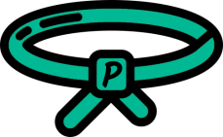  Green Belt 1
Arena 1 #2 |  |  | Arena 2 #2 |  |  | Sprints(Min:3 weeks, Max: 8 weeks)
# | Sprints (Min: 3 weeks, Max: 8 weeks) |  | # | Sprints (Min: 3 weeks, Max: 6 weeks) |  | 1 | expository essay + persuasive techniques
1 | Thesis Statement and counter argument writing |  | 1 | Use of hyperbole, stereotyping, and anecdote + grammatical conventions
 |  |  |  |  |  | 2 | Practice
2 | Paraphrasing and summarizing texts |  | 2 | writing process and genres + rhetorical devices |  | 3 | Review/Assessment
3 | Review/Assessment |  | 3 | Review/Assessment
White Belt 2 |  |  | Yellow Belt 2
© Copyright 2018, Parinama Academy, or its Affiliates. All rights reserved.

